Andrew Cornelius
Department for Communities and Local Government
4/J6 Eland House
Bressenden Place
London SW1E 5DU

19 January 2009

Dear Mr Cornelius

CLG Consultation on Best Value and Procurement
- Workforce Matters in Best Value Authority Contracting

Please find attached the response of the Association of Police Authorities (APA), on behalf of police authorities in England and Wales, to the consultation issued by CLG referred to above.

You will see that the response document attached to this letter raises a number of queries and concerns on behalf of police authorities about the proposed changes to existing arrangements. We would welcome the opportunity of discussing these with you to see how these can be resolved.

Please do get in touch with cat.mcintyre@lga.gov.uk if you would like to arrange a meeting, or if you have any queries on our response.

Yours sincerely

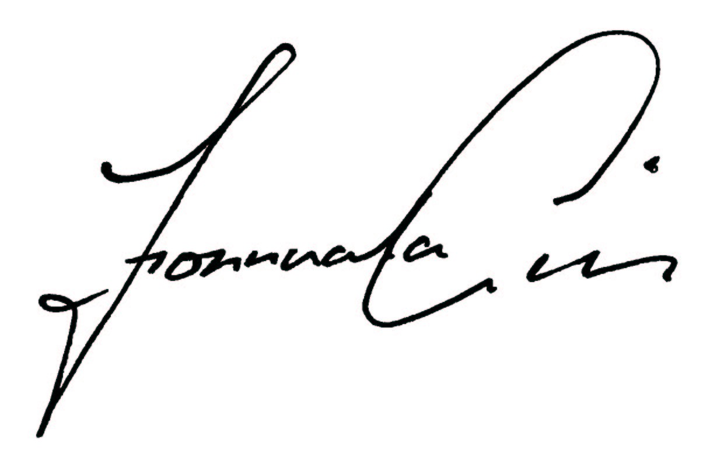
Fionnuala Gill
Executive Director

